CSA0501
DATABASE MANAGEMENT SYSTEMS
LAB EXPERIMENT
V sandeep
192525235
EXPERIMENT – 7
AIM
To view the records from the tables using SELECT commands with GROUP BY, HAVING and ORDER BY clauses.
PROCEDURE
- Open the MySQL Command Line Client and log in to the MySQL server.
- Select the required database using the USE CollegeDB; command.
- Verify the available tables using the SHOW TABLES; command.
- Verify the records available in the STUDENT, COURSE, MARKS and FACULTY tables.
- Use the GROUP BY clause to group records based on common column values.
- Use the COUNT() aggregate function to calculate the number of students registered for each course.
- Use GROUP BY with COUNT() to find the number of courses registered by each student.
- Use the ORDER BY ASC clause to arrange student records in ascending order of registration number.
- Use the ORDER BY DESC clause to arrange faculty members from oldest to youngest.
- Execute all the SELECT queries, verify the results and record the outputs.

QUESTIONS
GROUP BY – HAVING
1. How many students are registered for each course? Display the course description and the number of students registered in each course.
2. How many courses did each student register for?
ORDER BY
3. Retrieve Name, Gender, Mobile No of all the students in ascending order of Reg No.
4. List the faculty members in the order of older faculty first.
Outputs :
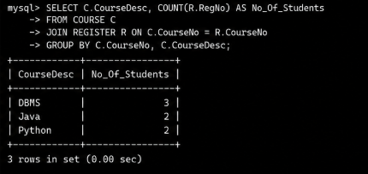
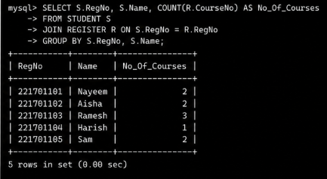
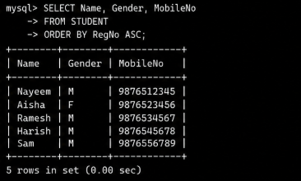
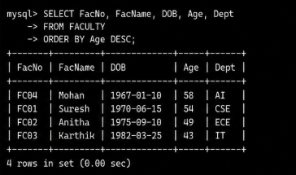
RESULT
The SELECT statements using GROUP BY, HAVING and ORDER BY clauses were successfully executed, and the required records were grouped, filtered and sorted accordingly.

